# Quinte Financial Technologies | FinTech Solutions

**Assignment on**

**CORE BANKING SYSTEM AND ATM**

**Under Supervision of:**

**Mr. Mohammad Mozammil**

**Submitted On:**

**8th July, 2024**

**Submitted By:**

**Archita Gupta**

# 

Table of Contents

Core Banking System 3

Automated Teller Machine (ATM) 11

# Core Banking System

Core banking is a back-end system that connects multiple branches of the same bank together to deliver operations like loan management, withdrawals, deposits and payments in real-time.

It is the software that banks use to manage their most critical processes, such as customer accounts, transactions and risk management and is essential for providing a seamless customer experience (CX) and maintaining compliance with regulations.

Core banking systems can be either on premises or cloud-based. On-premises systems are installed and maintained on the bank's own servers, while cloud-based systems are hosted by a third-party provider.

Some of the most popular core banking systems are the following:

* **Finacle.** This system is developed by Infosys and is used by over 1 billion customers in over 100 countries.
* **Oracle Banking Cloud Services.** This system is developed by Oracle and is used by over 130 banks in over 70 countries.

**Key Features:**

* **Account Management**: Core banking systems handle the management of various account types, such as savings, checking, and fixed deposits, providing real-time updates and balance checks to ensure accurate and timely information for both banks and customers.
* **Transaction Processing**: These systems facilitate the processing of deposits, withdrawals, transfers, and payments, including support for automated clearing house (ACH) transactions, wire transfers, and online payments, ensuring smooth and efficient transaction handling.
* **Loan and Credit Management**: Core banking systems manage personal, mortgage, and business loans, including credit scoring and risk assessment, helping banks to efficiently handle lending operations and assess borrower risk.
* **Customer Relationship Management (CRM)**: They maintain customer profiles and interaction histories, enabling banks to enhance customer service through personalized experiences and facilitating cross-selling and up-selling of financial products.
* **Compliance and Reporting**: These systems ensure adherence to regulatory requirements and standards, generating financial statements and regulatory reports, which helps banks stay compliant with laws and regulations.
* **Security and Fraud Detection**: Core banking systems implement multi-factor authentication (MFA) and real-time fraud detection and prevention mechanisms to protect against unauthorized access and fraudulent activities.
* **Integration Capabilities**: They integrate seamlessly with ATMs, internet banking, mobile banking, and other channels, as well as interfacing with third-party applications and services, providing a cohesive and comprehensive banking experience.

**Pros and Cons of Core Banking Systems:**

**Pros**:

* **Efficiency**: Automates routine banking processes, reducing manual workload and errors, and increasing operational efficiency.
* **Customer Convenience**: Enables customers to access their accounts and perform transactions from anywhere at any time, enhancing user experience.
* **Cost Savings**: Reduces operational costs by streamlining banking operations, allowing banks to allocate resources more effectively.
* **Improved Decision Making**: Provides real-time data and analytics to aid in strategic decision-making, helping banks respond to market changes swiftly.
* **Scalability**: Can accommodate the growth of banking operations and customer base, ensuring the system grows with the bank.

**Cons**:

* **Data Migration**: Moving data from legacy systems to the new core banking system can be complex and time-consuming, posing significant challenges.
* **Customization**: Adapting the system to fit specific banking requirements and workflows may require extensive customization, which can be costly.
* **Training**: Ensuring that staff are adequately trained to use the new system can be resource-intensive, requiring significant investment in training programs.
* **Downtime**: Minimizing disruption during the transition phase can be challenging, as any downtime can impact banking operations and customer satisfaction.

**How Core Banking Works:**

When a customer performs a transaction, like withdrawing money from a branch or an ATM, the application sends a request to a centralized data center. This data center processes the request, authenticates the operation, and updates the account accordingly.

The data center comprises several key components:

1. **Database**: Stores all customer and transaction data.
2. **Application Server**: Handles the core banking applications and processing logic.
3. **Web Server**: Manages online banking interfaces and interactions.
4. **Firewall**: Protects the system from unauthorized access and malware attacks.

* **Hosting Options**: Local or cloud-based data centers.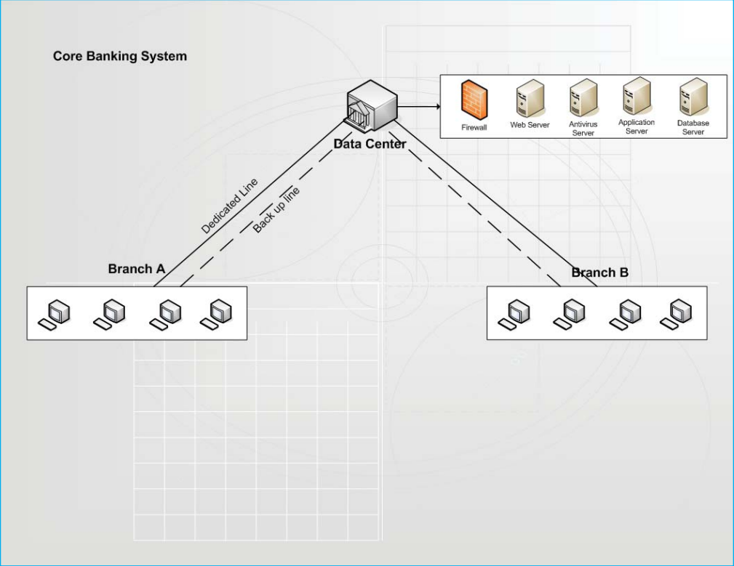

**Risk Management in Core Banking Systems:**

Risk management in core banking systems involves identifying, assessing, and mitigating various risks to ensure the stability and security of banking operations.

Different types of risk associated with the core banking system are:

1. **Operational Risk**: The risk arising from direct or indirect loss to the bank due to inadequate or failed internal processes, people, and systems. It includes several components:
   * **Processing Risk**: Occurs due to errors in data entry or faulty reporting of important market developments to bank management.
   * **Information Security Risk**: Involves the impacts to an organization and its stakeholders from threats and vulnerabilities associated with information systems and their operating environments.
   * **Legal Risk**: Arises from the treatment of clients, the sale of products, or business practices of a bank.
   * **Compliance Risk**: Exposure to legal penalties, financial penalties, and material loss due to failure to adhere to industry laws, regulations, internal policies, or best practices.
   * **People Risk**: Stems from the lack of trained personnel, tampering of records, unauthorized access to dealing rooms, and collusion between front and back-end offices.
2. **Credit Risk**: The risk that an asset or a loan becomes irrecoverable in the case of outright default, or the risk of unexpected delays in the servicing of a loan.
3. **Market Risk**: Refers to the risk of losses in the bank’s trading book due to changes in equity prices, interest rates, credit spreads, foreign-exchange rates, commodity prices, and other market indicators.
4. **Strategic Risk**: Sometimes referred to as business risk, it is defined as the risk that earnings decline due to a changing business environment, such as new competitors, mergers or acquisitions, or changing customer demands.
5. **IT Risk**: Common IT risks related to core banking systems include:
   * **Ownership of Data/Process**: Ensuring clear ownership and responsibility for data and processes.
   * **Authorization Process**: Proper authorization procedures to control access to systems and data.
   * **Authentication Procedures**: Strong authentication methods to verify user identities.
   * **Software Interfaces**: Managing several software interfaces across diverse networks.
   * **Maintaining Response Time**: Ensuring timely response and system performance.
   * **User Identity Management**: Effective management of user identities and access privileges.
   * **Access Controls**: Implementing robust access control mechanisms.
   * **Incident Handling Procedures**: Procedures for effectively handling and mitigating incidents.
   * **Change Management**: Managing changes to systems and processes to minimize disruption and risk.

To manage

* **Operational Risk:** Banks implement data validation, automated reporting, and regular audits and use encryption, firewalls, security assessments, and employee training and maintain thorough documentation, ensure compliance, and consult legal experts. They also implement compliance management systems, conduct audits, provide continuous training, enforce access controls, and conduct background checks.
* **Credit Risk**: Banks use advanced credit scoring, diversify loan portfolios, monitor loans, and set clear loan policies.
* **Market Risk**: Banks use risk modeling, implement hedging strategies, conduct stress tests, and stay updated on market trends.
* **Strategic Risk**: Banks perform strategic reviews, diversify products, develop contingency plans, and innovate continuously.
* **IT Risk**: Banks define roles and establish data governance, implement role-based access and multi-factor authentication, use advanced authentication technologies, secure and test interfaces regularly and monitor performance to optimize infrastructure. They also enforce strict policies and review logs, use IAM systems and audit user accounts, establish response plans and implement formal processes and test changes thoroughly.

### Price Segmentation in Core Banking Systems

Price segmentation in core banking systems involves offering different pricing strategies based on customer segments to maximize revenue and customer satisfaction. Here are the key aspects:

1. **Customer Segmentation**:
   * **Demographic Segmentation**: Dividing customers based on age, gender, income, etc.
   * **Behavioral Segmentation**: Analyzing customer behavior, such as spending patterns, product usage, and transaction frequency.
   * **Geographic Segmentation**: Segmenting customers based on their location.
2. **Product Segmentation**:
   * **Basic vs. Premium Accounts**: Offering different account types with varying features and fees.
   * **Loan Products**: Varying interest rates and terms for different customer segments.
   * **Service Packages**: Bundling services like insurance, investment options, and advisory services tailored to different segments.
3. **Pricing Strategies**:
   * **Tiered Pricing**: Offering different pricing tiers based on the level of service or features.
   * **Dynamic Pricing**: Adjusting prices based on demand, competition, and market conditions.
   * **Discounts and Promotions**: Providing special offers and discounts to attract and retain specific customer segments.
4. **Data Analytics**:
   * **Customer Insights**: Using data analytics to gain insights into customer preferences and behaviors.
   * **Personalization**: Tailoring products and pricing to meet the specific needs of individual customers or segments.
   * **Predictive Modeling**: Forecasting future customer behavior to optimize pricing strategies.

**Price Segmentation in Core Banking Systems:**

Price segmentation in core banking systems involves offering different pricing strategies based on customer segments to maximize revenue and customer satisfaction.

Some key aspects are:

1. **Customer Segmentation**:
   * **Demographic Segmentation**: Dividing customers based on age, gender, income, etc.
   * **Behavioral Segmentation**: Analyzing customer behavior, such as spending patterns, product usage, and transaction frequency.
   * **Geographic Segmentation**: Segmenting customers based on their location.
2. **Product Segmentation**:
   * **Basic vs. Premium Accounts**: Offering different account types with varying features and fees.
   * **Loan Products**: Varying interest rates and terms for different customer segments.
   * **Service Packages**: Bundling services like insurance, investment options, and advisory services tailored to different segments.
3. **Pricing Strategies**:
   * **Tiered Pricing**: Offering different pricing tiers based on the level of service or features.
   * **Dynamic Pricing**: Adjusting prices based on demand, competition, and market conditions.
   * **Discounts and Promotions**: Providing special offers and discounts to attract and retain specific customer segments.
4. **Data Analytics**:
   * **Customer Insights**: Using data analytics to gain insights into customer preferences and behaviors.
   * **Personalization**: Tailoring products and pricing to meet the specific needs of individual customers or segments.
   * **Predictive Modeling**: Forecasting future customer behavior to optimize pricing strategies.

**Fundamentals in Core Banking Systems:**

1. **Data Integrity**:

* **Accurate and Consistent Data**: Ensures correct and reliable data entry for maintaining customer accounts and transaction records.
* **Real-time Processing**: Keeps account balances and transaction histories up-to-date.
* **Data Validation**: Implements strict rules to prevent incorrect or incomplete data entry.

1. **Security**:

* **Multi-Factor Authentication (MFA)**: Secures system access with multiple verification methods.
* **Encryption**: Protects sensitive data in transit and at rest using advanced techniques.
* **Fraud Detection**: Uses sophisticated algorithms and tools to detect and prevent fraud.

1. **Scalability**:

* **Handling Growth**: Manages increasing transactions and customers without performance loss.
* **Modular Architecture**: Allows easy upgrades and new feature additions.
* **Cloud Integration**: Uses cloud technology to dynamically scale resources.

1. **Reliability**:

* **High Availability**: Ensures 24/7 system availability with minimal downtime.
* **Disaster Recovery**: Implements plans to restore operations quickly after failures.
* **Consistent Performance**: Maintains performance during peak times.

1. **Regulatory Compliance**:

* **Adherence to Standards**: Complies with national and international banking regulations.
* **Reporting and Auditing**: Regularly generates reports and conducts audits.
* **AML and KYC**: Implements Anti-Money Laundering (AML) and Know Your Customer (KYC) processes.

**Data Points:**

* 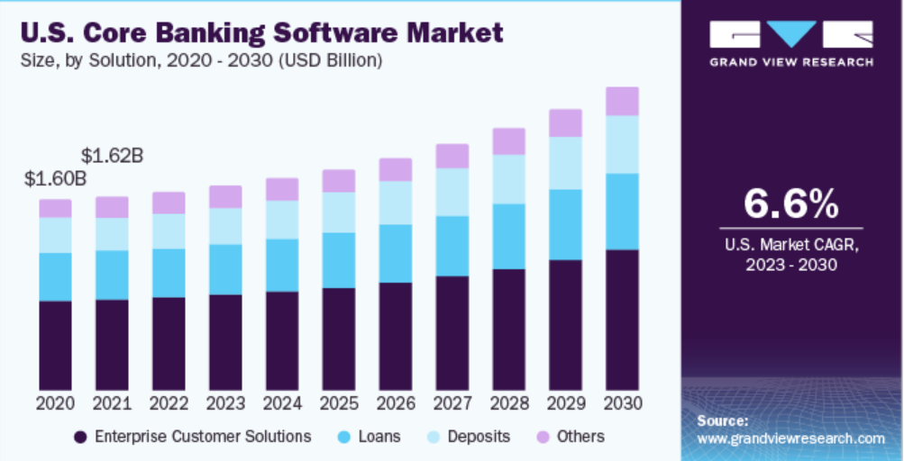Core banking software market size was approximately $1.60 billion in 2020 and projected CAGR is 6.6% from 2023 to 2030. The rise of the market is due to the increasing integration of technology for basic banking transactions and services.
* 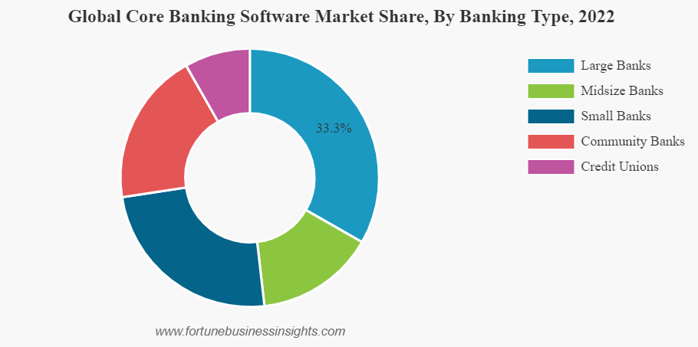The global core banking software market in 2022 was dominated by large banks with a 33.3% share, followed by midsize banks, small banks, community banks, and credit unions, indicating a diverse but top-heavy market distribution across different banking types.

# Automated Teller Machine (ATM)

An Automated Teller Machine (ATM) is a specialized computer that allows bank customers to perform financial transactions without the need for a human teller or direct interaction with bank staff. ATMs are typically located in public places such as bank branches, shopping centers, and airports, making banking services more accessible.

A cash machine was put into use by Barclays Bank, Enfield, in the United Kingdom, on 27 June 1967, which is recognized as the world's first ATM.

**Features of ATMs**

1. **Cash Withdrawal**: Allows customers to withdraw cash from their accounts using a debit or credit card.
2. **Balance Inquiry**: Enables customers to check the balance of their accounts.
3. **Fund Transfer**: Facilitates the transfer of money between accounts.
4. **Deposits**: Some ATMs accept cash and check deposits.
5. **Mini Statements**: Provides a brief statement of recent transactions.
6. **PIN Change**: Allows users to change their Personal Identification Number (PIN).
7. **Bill Payments**: Enables payment of utility bills, credit card bills, and other services.
8. **Multilingual Support**: Provides services in multiple languages to cater to diverse users.
9. **24/7 Availability**: Operates around the clock, providing banking services at any time.

**Types of ATMs**

1. **Onsite ATMs**: Located within or near a bank branch.
2. **Offsite ATMs**: Located outside of bank branches, such as in malls, airports, or grocery stores.
3. **White Label ATMs**: Operated by non-bank entities, allowing customers of multiple banks to use them.
4. **Brown Label ATMs**: Owned by banks but managed by third-party service providers.
5. **Cash Deposit ATMs (CDMs)**: Specifically designed for cash deposits.
6. **Smart ATMs**: Advanced machines that offer a wider range of services, including video conferencing with bank staff.

**Pros of ATMs**

1. **Convenience**: Provide 24/7 access to banking services.
2. **Time-Saving**: Reduce the need to visit a bank branch and wait in line.
3. **Wide Availability**: Located in various public places, enhancing accessibility.
4. **Multilingual Support**: Cater to users who speak different languages.
5. **Self-Service**: Allow customers to perform transactions independently.
6. **Efficient Transactions**: Enable quick and efficient handling of transactions.

**Cons of ATMs**

1. **Security Risks**: Vulnerable to skimming, hacking, and physical attacks.
2. **Technical Issues**: Can malfunction or run out of cash, causing inconvenience.
3. **Limited Services**: Cannot provide the full range of banking services available at branches.
4. **Fees**: May charge fees for transactions, especially when using an ATM outside the customer’s bank network.
5. **Accessibility**: May not be user-friendly for elderly or disabled individuals.
6. **Fraud**: Potential for card cloning, PIN theft, and other fraudulent activities.

## ATM Design Elements:

## The design of each ATM may be different, but they all contain the same basic parts:

* **Card reader**: This part reads the chip on the front of your card or the magnetic stripe on the back.
* **Keypad**: The keypad is used to input information, including your personal identification number (PIN), the type of transaction required, and the amount of the transaction.
* **Cash dispenser**: Bills are dispensed through a slot in the machine, which is connected to a safe at the bottom of the machine.
* **Printer**:If required, you can request receipts that are printed out of the ATM. The receipt records the type of transaction, the amount, and the current account balance.
* **Screen**: The ATM issues prompts that guide you through the process of executing the transaction. Information about accounts and their balances is also transmitted on the screen.

**Hardware:**

An ATM is typically made up of the following devices:

* CPU (to control the user interface and transaction devices)
* Magnetic or chip card reader (to identify the customer)
* a PIN pad for accepting and encrypting personal identification number EPP4 (similar in layout to a touch tone or calculator keypad), manufactured as part of a secure enclosure
* Secure cryptoprocessor, generally within a secure enclosure
* Display (used by the customer for performing the transaction)
* Function key buttons (usually close to the display) or a touchscreen (used to select the various aspects of the transaction)
* Record printer (to provide the customer with a record of the transaction)
* Vault (to store the parts of the machinery requiring restricted access)
* Housing (for aesthetics and to attach signage to)
* Sensors and indicators

**Software Used in ATMs:**

ATMs rely on specialized software components to ensure secure and efficient operations:

* Operating System: Typically embedded OS like Windows Embedded or Linux, optimized for ATM hardware.
* Application Software: Manages transactions (withdrawals, deposits), user interface, security (encryption, anti-fraud), and integration with banking systems.
* Middleware: Facilitates communication between hardware components and the OS, includes device drivers and security middleware.

**Security:**

Security is crucial for ATMs due to their nature as cash-dispensing machines and their susceptibility to various threats:

* **Physical Security**: ATMs are equipped with robust physical security measures such as reinforced casings, security cameras, and alarms to deter theft and vandalism.
* **Encryption and Data Protection**: All communication between the ATM and the banking network is encrypted to protect customer data from interception.
* **Anti-Skimming Measures**: Modern ATMs employ anti-skimming technologies to detect and prevent card data theft.
* **PIN Protection**: PINs are encrypted and stored securely within the ATM's hardware to prevent unauthorized access.

**Reliability:**

ATMs are designed for high reliability and availability:

* **Hardware Redundancy**: Critical components like cash dispensers and card readers often have redundant backups to minimize downtime.
* **Monitoring Systems**: Continuous monitoring systems detect issues in real-time, allowing for proactive maintenance and swift resolution of problems.
* **Backup Power**: ATMs are equipped with backup power sources, such as batteries or generators, to ensure operation during power outages.
* **Service Level Agreements (SLAs)**: Banks typically maintain SLAs with ATM service providers to ensure uptime and performance standards.

**Fraud:**

ATMs face several fraud risks, necessitating robust preventive measures:

* **Skimming**: Criminals attach devices to ATMs to capture card details and PINs.
* **Card Trapping**: Mechanisms within the card slot can trap cards, allowing criminals to retrieve them later.
* **Phishing and Social Engineering**: Fraudsters may attempt to trick users into revealing their PINs or other sensitive information.
* **Malware Attacks**: ATMs are vulnerable to malware that can compromise their security and operations.
* **Physical Attacks**: Criminals may attempt to break into ATMs to steal cash or compromise the machine's security.

**Impact on Labor:**

ATMs have significantly impacted labor within the banking sector:

* **Reduction in Routine Transactions**: ATMs automate routine transactions such as cash withdrawals and balance inquiries, reducing the need for tellers to handle these tasks manually.
* **Shift in Teller Roles**: Bank staff roles have shifted towards more complex customer service tasks, advisory roles, and sales, where human interaction and expertise are valued.
* **Job Redefinition**: While some repetitive tasks have been automated, the demand for skilled professionals to manage and maintain ATMs has increased.

**Data Points:**

* As of 2023, there were approximately 455,000 ATMs in US, a decrease from about 470,000 in 2020. Factors contributing to this decline include:
  + Increased use of digital payment methods
  + Bank branch closures
  + Consolidation in the banking industry
  + Rising maintenance costs

**Recent Developments:**

1. **Cardless Transactions**:
   * Many major banks like Bank of America, Wells Fargo, and Chase offer cardless ATM access via mobile apps or digital wallets (Apple Pay, Google Pay).
   * By the end of 2023, about 60% of ATMs in the US support cardless transactions.
2. **Enhanced Functionality**:
   * Modern ATMs offer more services: instant check cashing, bill payments, account management (PIN changes, contact updates, account opening), and foreign currency exchange.
   * A 2023 survey found that 78% of financial institutions plan to expand ATM functionality within the next two years.
3. **Bitcoin ATMs**:
   * Rapid growth with over 50,000 Bitcoin ATMs in the US by early 2024, up from 30,000 in early 2022, representing a 65% growth rate in two years.

**Challenges faced by ATMs:**

1. **Maintenance Costs**:
   * Annual costs have risen:
     + Basic ATM: $3,500 - $7,500
     + Advanced ATM: Up to $10,000
   * Includes cash replenishment, technical maintenance, security updates, and regulatory compliance.
2. **Security Threats**:
   * **ATM Skimming**: Significant issue, with $200 million in fraud losses reported in 2023.
   * **Jackpotting Attacks**: More sophisticated; 23 incidents in 2023 resulted in losses over $5 million.
3. **Declining Usage**:
   * ATM transactions are decreasing, with an 8% annual decline from 2020 to 2023.
   * Only 45% of millennials reported regular ATM use in 2023, down from 58% in 2020.

**Security Measures for ATMs:**

1. **EMV Chip Technology**: Over 95% of US ATMs are EMV-compliant as of 2024, reducing card cloning risks.
2. **Anti-Skimming Devices**:
   * **Jitter Devices**: Prevent skimmers from reading card data by creating a varying magnetic field.
   * **Detection Systems**: Sense foreign devices and alert operators.
   * ATMs with advanced anti-skimming tech experienced 73% fewer skimming attempts (2023 ATM Industry Association report).
3. **Encryption**: End-to-end encryption using AES-256 is the industry standard, ensuring secure data transmission.
4. **Biometric Authentication**: Around 5% of US ATMs offer biometric authentication (fingerprint or palm vein scanning) as of 2024.

**Improvisation:**

1. **AI-Powered Fraud Detection**: AI algorithms detect fraudulent patterns in real-time, reducing fraud losses by 35% compared to traditional methods (2023 Javelin Strategy & Research study).
2. **Remote Monitoring**: IoT sensors and cameras enable real-time ATM monitoring, reducing response times to issues from 4-6 hours in 2020 to 2-3 hours in 2023.
3. **Cash Recycling**: About 25% of US ATMs have cash recycling capabilities as of 2024, cutting cash replenishment costs by up to 40%.

**Comparison of ATMs in Different Countries:**

1. **United States**
   * **ATM Density**: 174 per 100,000 adults
   * **Unique Features**:
     + Drive-through ATMs
     + Bank-neutral ATMs in convenience stores
     + Cardless access (60% of ATMs as of 2023)
     + Growing number of Bitcoin ATMs (over 50,000 as of early 2024)
   * **Average Withdrawal**: $80 per transaction (2023 data)
   * **Fees**: $4.64 average out-of-network fee (2023 data)
2. **Japan:**
   * **ATM Density**: 127 per 100,000 adults
   * **Unique Features**:
     + Limited operating hours
     + Multilingual interfaces (English, Chinese, Korean)
     + High-tech features like fingerprint authentication
     + Passbook updates
   * **Fees**: Fees for use outside business hours or for cards from other banks
   * **Cash Preference**: Largely cash-based society
3. **India:**
   * **ATM Density**: 22 per 100,000 adults
   * **Unique Features**:
     + Biometric authentication (Aadhaar)
     + Solar-powered ATMs in rural areas
     + Micro-ATMs for rural inclusion
     + Some ATMs dispense gold coins
   * **Government Initiatives**: Push for rural ATM deployment
   * **Security**: Armed guards common
4. **United Kingdom:**
   * **ATM Density**: 100 per 100,000 adults
   * **Unique Features**:
     + Charity donation options
     + Contactless technology
     + Multiple currencies in tourist areas
   * **Fees**: About 70% of ATMs are free to use (2023 data)
   * **Trend**: Reduction in ATMs, especially in rural areas

Thank You